SRE Assignment – 1
Reverse Proxy Configuration using Apache and Nginx
1. Objective
The objective of this assignment is to configure password-less SSH authentication between three Ubuntu virtual machines and implement reverse proxy functionality using Apache and Nginx web servers.
2. Environment Details
- OS: Ubuntu 24.04.3 LTS
- Hypervisor: VMware
- Number of Virtual Machines: 3

VM Specifications
Each virtual machine was allocated the following resources:
RAM: 4 GB
CPU: 2 Cores
Disk: 20 GB
Network Mode: NAT / Host-Only
Virtual Machine Details

VM Name | Hostname | Username | IP Address
VM1 | vm1 | machine1 | 192.168.198.128
VM2 | vm2 | machine2 | 192.168.198.129
VM3 | vm3 | machine3 | 192.168.198.130

3.Configure Password-less SSH Authentication Between All VMs
Install OpenSSH Server
On all virtual machines:
sudo apt update
sudo apt install openssh-server -y
Enable and Start SSH Service
sudo systemctl enable ssh
sudo systemctl start ssh
Generate SSH Keys
ssh-keygen

key Generation
VM1
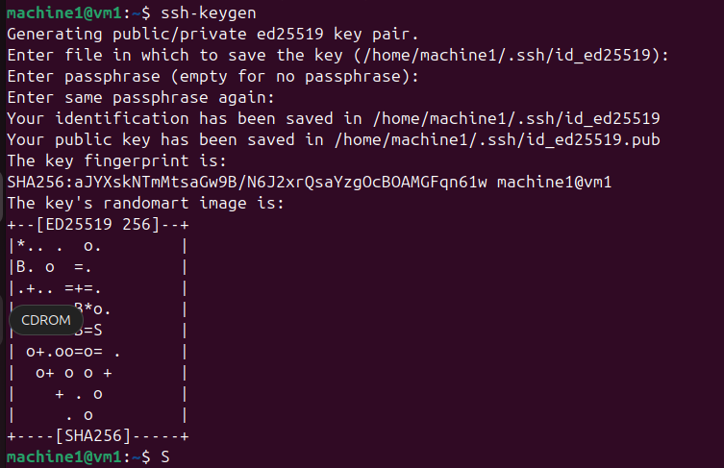
VM2
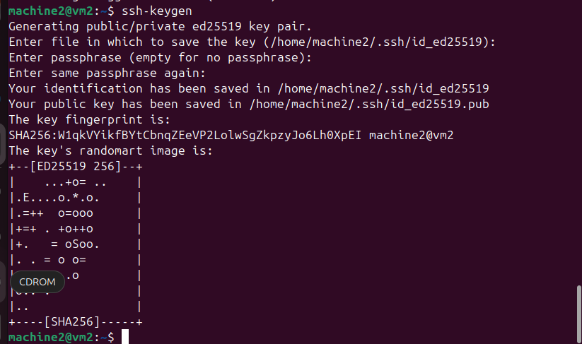
VM3
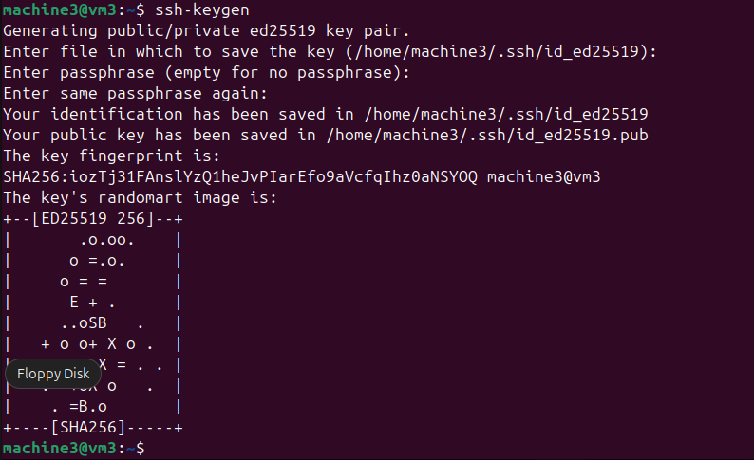
Copy SSH Keys Between VMs
From VM1:
ssh-copy-id machine2@192.168.198.129
ssh-copy-id machine3@192.168.198.130
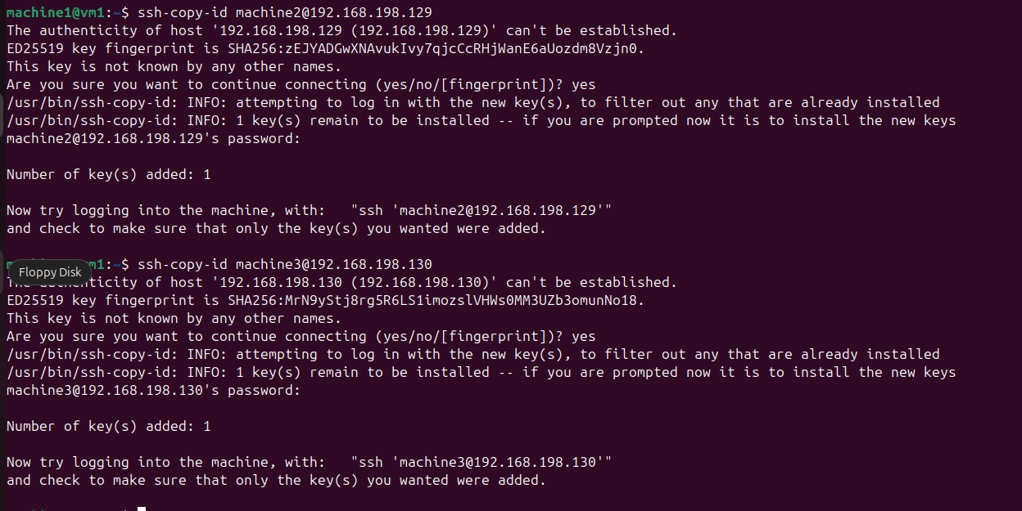
From VM2:
ssh-copy-id machine1@192.168.198.128
ssh-copy-id machine3@192.168.198.130
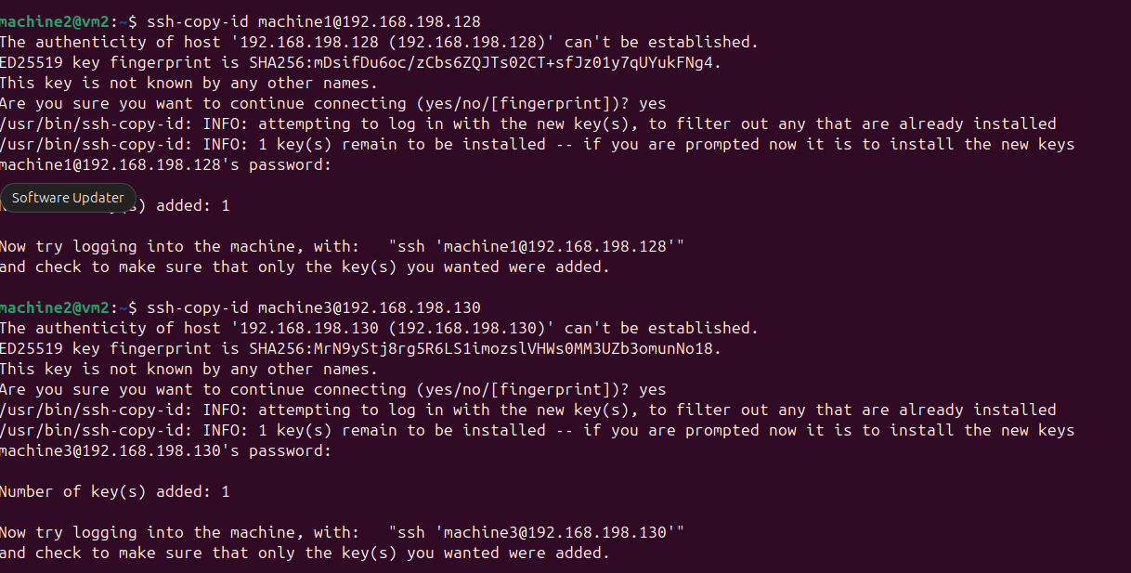
From VM3:
ssh-copy-id machine1@192.168.198.128
ssh-copy-id machine2@192.168.198.129
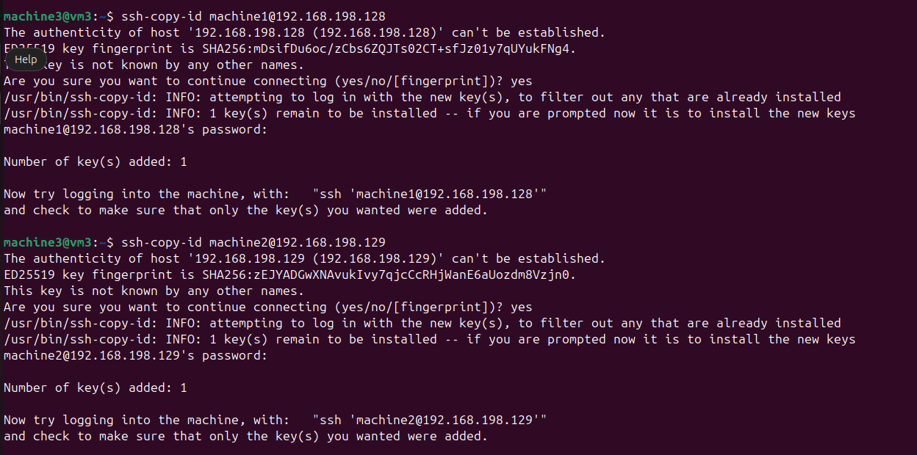
This enables password-less SSH login between all virtual machines.

4.Install Apache Web Server on All VMs
Apache Installation
sudo apt update
sudo apt install apache2 -y
Create Test HTML Pages
- VM1: “This is VM1”
- VM2: “This is VM2”
- VM3: “This is VM3”
Example:
echo "<h1>This is VM1</h1>" | sudo tee /var/www/html/index.html
. Apache was verified by accessing each VM’s IP address in a web browser.

5.Configure Reverse Proxy for Apache
Enable Apache Proxy Modules
sudo a2enmod proxy
sudo a2enmod proxy_http
sudo systemctl restart apache2
Example (VM1):
Edit the 000-default.conf file
sudo nano /etc/apache2/sites-available/000-default.conf
<VirtualHost *:80>

ServerAdmin webmaster@localhost
DocumentRoot /var/www/html

ProxyPass /app1 http://192.168.198.128/
ProxyPassReverse /app1 http://192.168.198.128/
sudo systemctl restart apache2

VM1
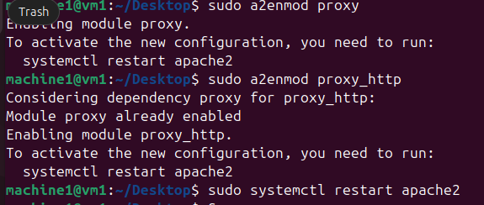
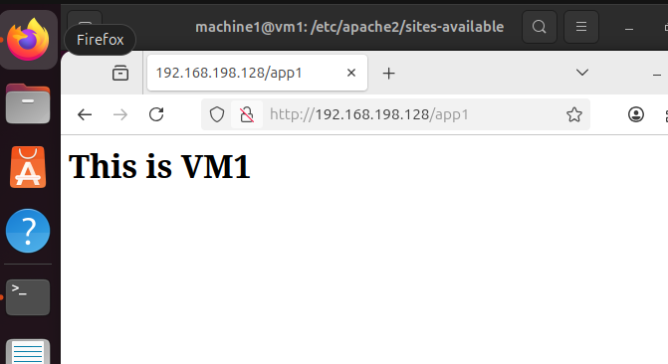

IN VM2
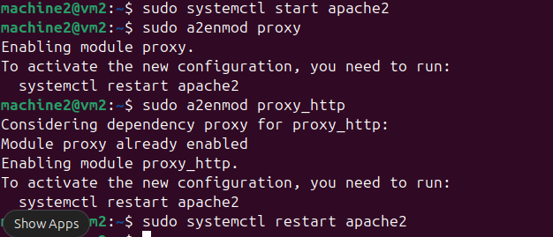

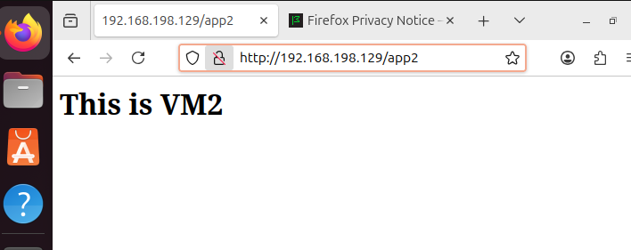

IN VM3

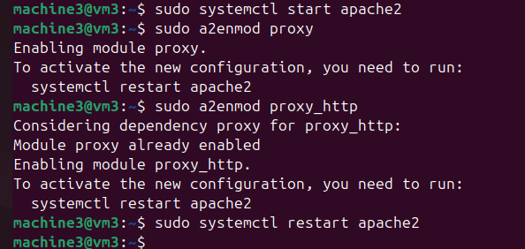

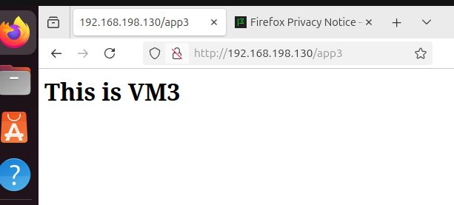

6.Install Nginx Web Server on All VMs
sudo apt install nginx -y
sudo systemctl enable nginx
sudo systemctl start nginx
EDIT THE DEFAULT FILE
sudo nano /etc/nginx/sites-available/default
. Inside server { } block:
location /app1/ {
proxy_pass http://192.168.198.128/;
proxy_set_header Host $host;
proxy_set_header X-Real-IP $remote_addr;
proxy_set_header X-Forwarded-For $proxy_add_x_forwarded_for;
}
In VM1
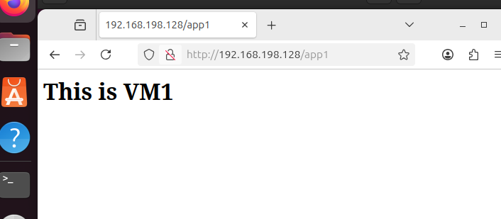

In VM2
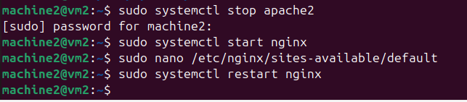
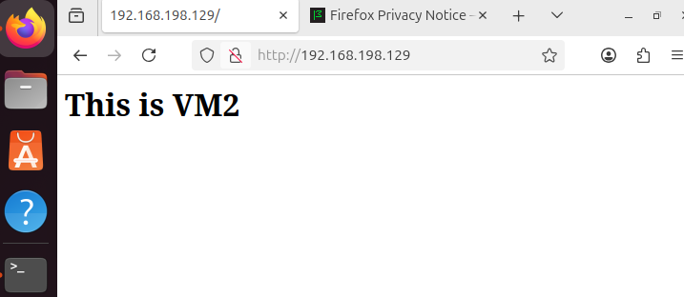
IN VM3
